TR-PAG-20108
产品简介 General Information
- TR-PAG-20108是一款新型阳离子光引发剂。其活性高，毒性低，稳定性好，主要应用于要求较高的阳离子体系，例如电子电路粘接剂。
- TR-PAG-20108 is a new cationic photoinitiator, which has high activity, low toxicity and good stability. It’s mainly used in cation curing with high requirements, as electronic adhesive.
产品信息 Product Information
- 化学名称 Chemical Name：二苯基-(4-苯基硫)苯基锍四(五氟苯)硼酸盐 Diphenyl-(4-phenylthio) phenyl sulfonium tetra (pentafluorobenzene) borate salt
- 分子量 Molecular Weight：1050.50
- CAS No：203573-06-2
紫外吸收光谱 UV Absorbance Spectrum
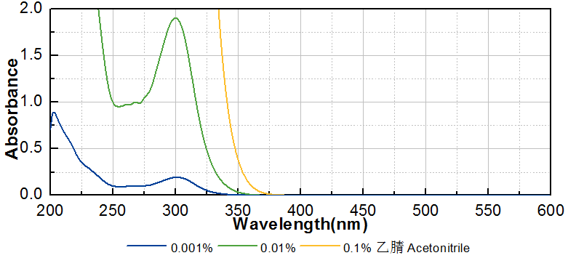
技术参数 Technical Parameters
- 外观 Appearance：类白色粉末 Off-white powder
- 纯度 Purity(HPLC)：≥98.50%
- 水分 Water Content：≤0.50%
产品优势 Benefits
- 高活性 High activity
- 低毒性 Low toxicity
- 高稳定性 Good stability
应用 Applications
- TR-PAG-20108主要应用于要求较高的阳离子体系，建议添加量为1~3%。
- TR-PAG-20108 is mainly used in cation curing with high requirements. The recommended dosage is 1~3%.
存储及包装 Storage & Packaging
- 保存在密闭容器中储存在阴凉、干燥、阴暗、通风的区域。自生产日期开始，1年内有效。包装：按订单生产。
- Keep in a tightly closed container and store in a cool, dry, dark, ventilated area. Effective from the date of production, within 1 year. Packaging: make to order.

THE END

