TR-PAG-20102P
产品简介 General Information
- TR-PAG-20102P是一款通用型阳离子光引发剂，溶解在碳酸丙烯酯中以便于使用。其活性高，稳定性好，主要应用于涂料、油墨、3D打印等阳离子体系。
- TR-PAG-20102P is a general cationic photoinitiator, which is dissolved in propylene carbonate for easy use. With high activity and good stability, it’s mainly used in cationic systems such as coating, ink and 3D printing.
产品信息 Product Information
- 化学名称 Chemical Name：二苯基-(4-苯基硫)苯基锍六氟锑酸盐 4-thiophenyl phenyl diphenyl sulfonium hexafluoroantimonate salt propylene carbonate solution
- CAS No：71449-78-0, 108-32-7
紫外吸收光谱 UV Absorbance Spectrum
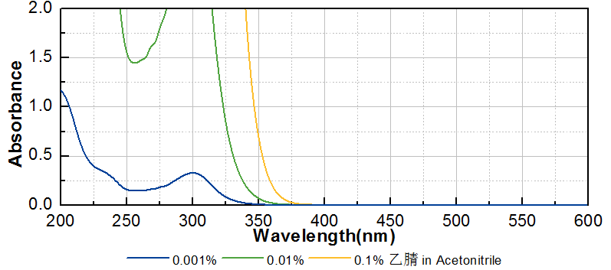
技术参数 Technical Parameters
- 外观 Appearance：淡黄色透明液体 Light yellow transparent liquid
- 固含量 Solid Content：45.00~55.00%
- 水分 Water Content：≤0.50%
产品优势 Benefits
- 高活性 High activity
- 高稳定性 Good stability
应用 Applications
- TR-PAG-20102P主要用于环氧树脂涂料、特种油墨、3D打印，建议添加量为1~3%。
- TR-PAG-20102P is mainly used for epoxy coating, special ink and 3D printing. The recommended dosage is 1~3%.
存储及包装 Storage & Packaging
- 保存在密闭容器中储存在阴凉、干燥、阴暗、通风的区域。自生产日期开始，2年内有效。包装：20kg/桶。
- Keep in a tightly closed container and store in a cool, dry, dark, ventilated area. Effective from the date of production, within 2 years. Packaging: 20kg/pail.

THE END

