TR-PAG-201S
产品简介 General Information
- TR-PAG-201S是一款通用型阳离子光引发剂。其活性高，性价比高，是最为成熟的阳离子光引发剂之一，主要应用于涂料、油墨、胶粘剂等阳离子体系。
- TR-PAG-201S is a general cationic photoinitiator, which is dissolved in propylene carbonate for easy use. With high activity and high cost performance, it is one of the most mature cationic photoinitiators, mainly used in cationic systems such as coating, ink and adhesive.
产品信息 Product Information

- 化学名称 Chemical Name：混合型三苯基六氟锑酸硫鎓盐Mixed type triphenyl sulfonium hexafluoroantimonate salt
- CAS No：89452-37-9, 71449-78-0
紫外吸收光谱 UV Absorbance Spectrum
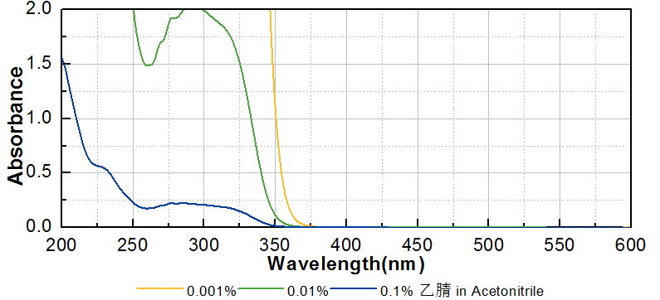
技术参数 Technical Parameters
- 外观 Appearance：类白色粉末 Off-white powder
- 纯度 Purity (HPLC)：≥99.00%
- 干燥失重 Loss on Drying：≤1.00%
产品优势 Benefits
- 高活性 High activity
- 优良的性价比 Good cost effectivity
应用 Applications
- TR-PAG-201S主要用于环氧树脂涂料、特种油墨、胶粘剂，建议添加量为1~3%。
- TR-PAG-201S is mainly used for epoxy coating, special ink and adhesive. The recommended dosage is 1~3%.
存储及包装 Storage & Packaging
- 保存在密闭容器中储存在阴凉、干燥、阴暗、通风的区域。自生产日期开始，2年内有效。包装：20kg/桶。
- Keep in a tightly closed container and store in a cool, dry, dark, ventilated area. Effective from the date of production, within 2 years. Packaging: 20kg/drum.

THE END

