TR-PPI-102
产品简介 General Information
- TR-PPI-102是一款大分子自由基光引发剂，具有低挥发、低迁移、低毒性、低黄变的特性，适用于各种人体直接接触材料，也适用于氧阻聚影响较大的薄涂层。
- TR-PPI-102S is a macromolecular free radical photoinitiator with the characteristics of low volatility, low migration, low toxicity and low yellowing. It is suitable for all kinds of materials in direct contact with human body, and also suitable for thin coatings with large impact of oxygen polymerization inhibition.
产品信息 Product Information
- 化学名称 Chemical Name：2-羟基-1-{3-[4-(2-羟基-2-甲基-丙酰基)-苯基]-1, 1, 3-三甲基-茚-5-基}-2-甲基丙酮 2-hydroxy-1-(3-[4(2-hydroxy-2-methyl-propionyl)-phenyl]-1,1,3-trimethyl-indan-5-yl}-2-methyl-propan-1-one
- CAS No：163702-01-0
紫外吸收光谱 UV Absorbance Spectrum
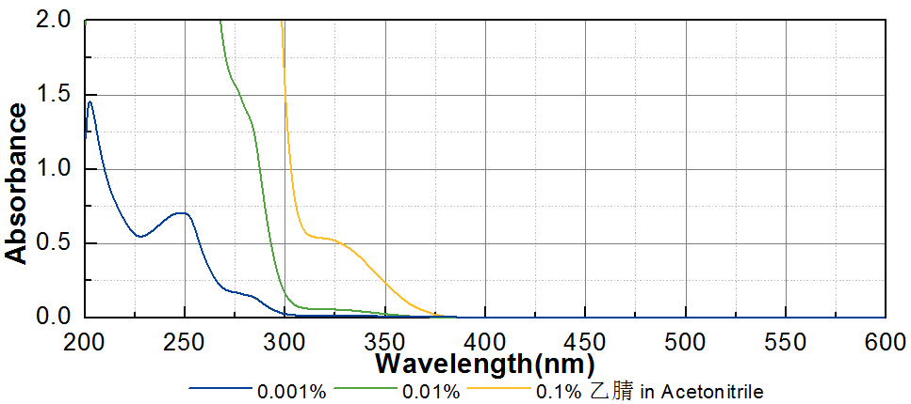

技术参数 Technical Parameters
- 外观 Appearance：非常粘稠黄色液体至固体 High-viscous yellow liquid to solid
- 纯度 Purity (HPLC)：≥95.00%
- 干燥失重 Loss on Drying：≤0.30%
产品优势 Benefits
- 低黄变 Low yellowing
- 低气味、低迁移、低毒性 Low odor, low migration, low toxicity
- 低氧阻聚 Low oxygen polymerization inhibition
- 高性价比 High cost-effectiveness
应用 Applications
- TR-PPI-102可应用于各种与人体直接接触材料，例如涂料和食品包装油墨。建议添加量为3~5%，使用前请预加热至80~100ºC以降低粘度。
- TR-PPI-102 can be applied to various materials in direct contact with human body, such as coating and food packaging ink. The recommended dosage is 3~5%. Please preheat to 80~100 ºC before use to reduce viscosity.
存储及包装 Storage & Packaging
- 保存在密闭容器中储存在阴凉、干燥、阴暗、通风的区域。自生产日期开始，2年内有效。包装：20kg/桶；50kg/桶。
- Keep in a tightly closed container and store in a cool, dry, dark, ventilated area. Effective from the date of production, within 2 years. Packaging: 20kg/pail, 50kg/drum.

THE END

