TR-PPI-101S
产品简介 General Information
- TR-PPI-101S是一款混合型大分子自由基光引发剂，具有低挥发、低迁移、低毒性、低黄变的特性，适用于各种人体直接接触材料，也适用于氧阻聚影响较大的薄涂层。TR-PPI-101S在树脂中有较高的溶解性，比TR-PPI-101更便于使用。
- TR-PPI-101S is a mixed macromolecular free radical photoinitiator with the characteristics of low volatility, low migration, low toxicity and low yellowing. It is suitable for all kinds of materials in direct contact with human body, and also suitable for thin coatings with large impact of oxygen polymerization inhibition. TR-PPI-101S has a high solubility in resin, it’s more convenient to use than TR-PPI-101.
产品信息 Product Information
- 化学名称 Chemical Name：混合型大分子光引发剂 Mixed macromolecular photoinitiator
- CAS No：163702-01-0, 7473-98-5
紫外吸收光谱 UV Absorbance Spectrum
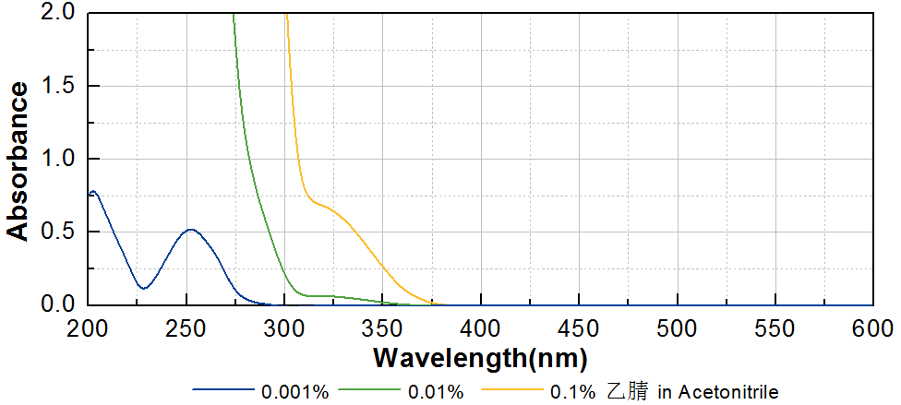

技术参数 Technical Parameters
- 外观 Appearance：黄色透明粘稠液体 Yellow transparent viscous liquid
- 水分 Water Content：≤0.50%
产品优势 Benefits
- 低黄变 Low yellowing
- 低气味、低迁移、低毒性 Low odor, low migration, low toxicity
- 低氧阻聚 Low oxygen polymerization inhibition
- 便于使用 Easy to use
应用 Applications
- TR-PPI-101S可应用于一些与人体直接接触材料，例如木器涂料。建议添加量为3~5%。
- TR-PPI-101S can be applied to some kinds of materials in direct contact with human body, such as wood coating. The recommended dosage is 3~5%.
存储及包装 Storage & Packaging
- 保存在密闭容器中储存在阴凉、干燥、阴暗、通风的区域。自生产日期开始，2年内有效。包装：25kg/桶；200kg/桶。
- Keep in a tightly closed container and store in a cool, dry, dark, ventilated area. Effective from the date of production, within 2 years. Packaging: 25kg/pail, 200kg/drum.

THE END

